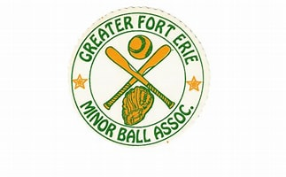
House League

Playing baseball or softball teaches kids far more than how to swing a bat or field a grounder—it shapes who they become. Out on the diamond, they discover the power of teamwork, learning that every voice matters and every effort lifts the whole team. They build patience and confidence as they chase improvement, celebrate the small victories, and rise after every stumble.
The game keeps their bodies moving and their minds sharp, but it also teaches something deeper: discipline, resilience, and pride in the work they put in. And most importantly, it gives kids a place to belong. It surrounds them with friends who cheer for them, challenges that help them grow, and moments of pure joy that remind them why they play.
Baseball and softball show kids that when you give your best, support your teammates, and stay committed even when things get tough, incredible things can happen. The lessons they learn between the foul lines stay with them long after the final out—shaping not simply better athletes, but stronger, more confident young people.

